

ALEX EKWUEME FEDERAL UNIVERSITY NDUFU-ALIKE IKWO,
EBONYI STATE, NIGERIA.
P.M.B 1010
FIELD TRIP REPORT ON THE VISIT TO NATIONAL ARBOVIRUS AND VECTOR RESEARCH CENTRE (NAVRC), ENUGU.
BY
OKORIE JOSEPH FRANCIS
2023/BS/27260
DEPARTMENT OF BIOTECHNOLOGY
FACULTY OF BIOLOGICAL SCIENCES
COURSE CODE: BTG 206

IN PARTIAL FUFILMENT OF THE AWARD OF BACHELOR OF SCIENCE DEGREE (B.Sc) IN BIOTECHNOLOGY.

3RD JULY, 2025.
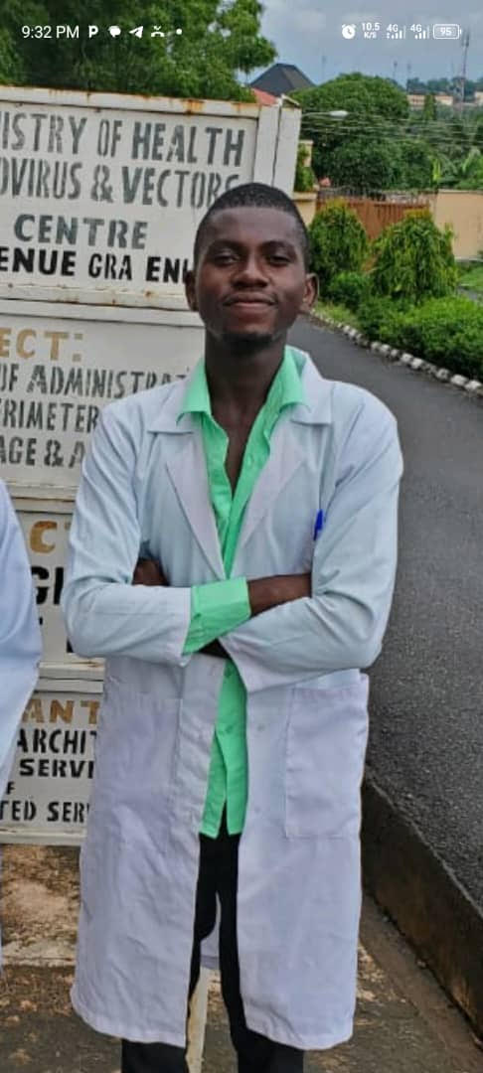

Certification
This is to certify that this report on field trip to National Arbovirus and Vector Research Centre (NAVRC) was written by Okorie Joseph Francis with Reg. No. 2023/BS/27260, under the supervision of Mrs, Jacinta N. Ofoegbu.

Okorie Joseph Francis ______________ ___________
Student Signature Date

Mrs, Jacinta N. Ofoegbu. ______________ ___________
Coordinator Signature Date

________________________ ______________ ___________
Head of Department Signature Date

Dedication
I would like to dedicate this work to my beloved sister Uche Nnenna, whose unwavering support and generosity made my field trip possible, your financial help came at the crucial time, and your kindness means more to me than words can express. Thank you for believing in me and always being there when I needed you. This journey was made easier because of you.

Acknowledgement
I extend my sincere gratitude to my brother and mum whose support has been a steady pillar in my life, whether through your words of encouragement or your quiet acts of kindness, you have always shown up when it mattered most. Your presence and believe in me have made a real difference, and I am deeply thankful to have you by my side.

TABLE OF CONTENTS
Title Page
Certification i
Dedication ii
Acknowledgements iii
Table of Contents iv
List of Tables vi
List of Figures vii
CHAPTER ONE
- Field Trip Location 1
  - Overview and History 1
  - Mission and Vision Statement 2
  - Arbovirus 4
CHAPTER TWO
  - Introduction to Insectory lab 5
  - Purposes of an insectory lab 5
  - Typical insectory lab features 5
  - Common Insects studied 6
  - Safety and Biosafety 7
CHAPTER THREE
  - Introduction to photochemistry lab 8
  - How experiments are done in a photochemistry lab 8
CHAPTER FOUR
  - Introduction to Molecular Lab 11
  - Units of Molecular Lab 11
  - Tools and Equipments in Molecular Lab 13
  - Summary 16
  - Conclusion 17
Reference 18

List of Tables
Table 1: Classification of Arbovirus 3
Table 2: Diseases caused by arbovirus 4
Table 3: Typical insectory lab features 5
Table 4: Common Quantitative Test 9
Table 5: PCR Ratio 11
Table 6: Thermocycle stages and duration 12

List of Figures
Figure 1: Aedes mosquito 6
Figure 2: Anopheles mosquito 6
Figure 3: Culex mosquito 6
Figure 4: Male tick 6
Figure 5: A male tsetse fly 7
Figure 6: A fruit fly 7
Figure 7: A soxhlet Extraction 9
Figure 8: A hand-held micropipette 13
Figure 9: An image of a centrifuge 14
Figure 10: A thermocycle 14
Figure 11: A spectrophotometer 15
Figure 12: Vortex machine 16

CHAPTER ONE
INTRODUCTION
  - Field Trip Location
Federal ministry of health National Arbovirus and Vector Research Centre is located at 33 park avenue GRA Enugu.
  - Overview and History
In 1973, the federal ministry of health invited the attention of WHO to the epidemic and epizootic outbreaks of arboviral infections in Nigeria between 1969 and 1973. Following this invitation, the government and WHO entered into a 5 years trans-continental disease control (TCDC) agreement to:
- Set up a specialized field research centre, to look specifically into the problems passed by arbovirus infections in Nigeria.
- Subsequently, device strategies and methods for effective containment of the vectors. Following preliminary assessment of arboviral activities in the country, WHO facilitated the establishement of a research centre for arbovirus in Nigeria known as the World Health Organization Arbovirus Vector Research Unit (WHO/AVRU) in Enugu
The TCDC contract agreement was extended to 1981 but before then there was a tripartite agreement between the federal ministry of health, WHO and then Anambra State Government, to the effect that the Anambra State Government would provide land and the property, the federal government will staff and find the operations of the centre and it will serve as a WHO collaborating centre for training and research with support from WHO. The name of the centre was subsequently changed to the national Arbovirus and Vector Research Centre, Enugu. (National Arbovirus and Vector Research Centre, n.d).

  - Mission and Vision
Vision: To be one of the leading research centre in the world
Mission: We shall be a centre of Excellency by establishing superior value for all aspects of research on arthropods-borne viruses and vector, sustaining quest of asking and providing solutions and adhering to the ethical standards (National Arbovirus and Vector Research Centre, n.d).

  - ARBOVIRUS
Arbovirus are a group of Arthropod-Borne virus that are transmitted by blood-sucking Arthropods, such as mosquites, ticks and sand flies. The word “Arbovirus” stands for “Arthropod-Borne Virus” (Hall et al, 2012)
Table 1: Classifications of Arbovirus
Family | Example o Arbovirus
Flaviridae | Dengue, zika, yellow fever, west nile
Togaviridae | Chikungunya
Bunyaviridae | Pift valley fever, crimen-congo hemorrhagic fever
Reoviridae | Colorado tick fever

Transmission: The transmission of arbovirus can be from any of the foillowing below:
- Arthropods
- Vectors
- Mosquitoe
- Tick
- Sandflies
The virus replicates in the athropods which then transmits it through bites

Table 2: Disesases Caused by Arbovirus
Virus | Disease | Vector
Dengue Virus | Dengue Fever | Aedes Mosquitoes
Zika virus | Zika fever | Aedes Mosquitoes
Chikungunya virus | Chikungunya | Aedes mosquitoes
Yellow fever virus | Yellow fever | Aedes mosquitoes
West nile virus | West nile fever | Cutex mosquitoes
Japanese encephalitis | Encephalitis | Cutex mosquitoes
Crimean-congo HF virus | Hemorrhagic Fever | Ticks

Diagnosis:
- PCR (Defeat Viral RNA)
- Serology (1g M/g G antibodies)

Purpose in Arbovirus Research
- Understanding virus transmission
- Vector control strategies
- Discovery of antiviral compounds
- Molecular detection and characterization
- Public health and disease survelliance

CHAPTER TWO
INSECTORY LAB
2.1 Introduction to Insectory Lab
An insectory lab is a specialized laboratory facility designed for rearing, studying and maintaining life insects especially those involved in research, disease transmission or biological control. (Pan American Health Organization, 2023)
2.2 Purposes of an Insectory Lab
- Vector Research: Study of mosquitoes, ticks, and other vector that transmit disease like malaria, dague, zika, etc. understanding vector biology, behavior and life cycle.
- Infectious disease studies: infectious insects with viruses, bacteria or parasites like arbovirus or malaria. Study of transmission dynamics and host pathogen infections.
- Vaccine and drug testing: testing the effectiveness of vaccines or insecticides. Research on vector resistance to control agent.
- Mass rearing: Production of large number of insects, for research or vector control programs (e.g sterile insect techniques).
- Biological control: rearing of beneficial insects like parasitoid wasps or predatory beetles for pest management.
2.3 Table 3: Typical Insectory Lab Features
Component | Purpose
Controlled room | Manage temperature humidity light
Cage and incubators | Rear insects safety and consistently
Feeding system | Blood-feeding system for mosquitoes, etc
Containment areas | Biosafety zones to prevent escape/infection
Microscopes/lab tools | Dissect and analyze insects

2.4 Common Insects Studied
- Mosquitoes (Aedes, Anopheles, Culex)
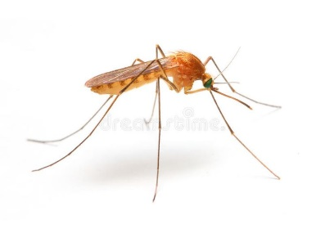
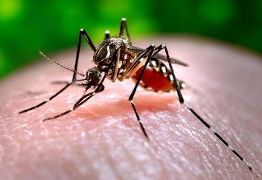

Fig. 1: Aedes Mosquito Fig. 2: Anopheles Mosquito
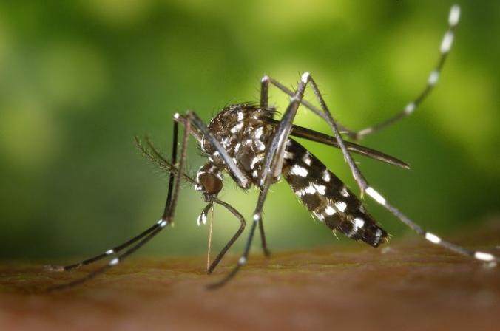

Fig. 3: Culex Mosqutio
- Tick
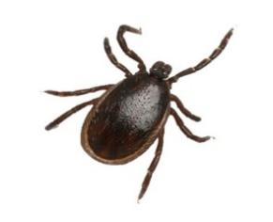

Fig.4: Male Tick
- Tsetse flies

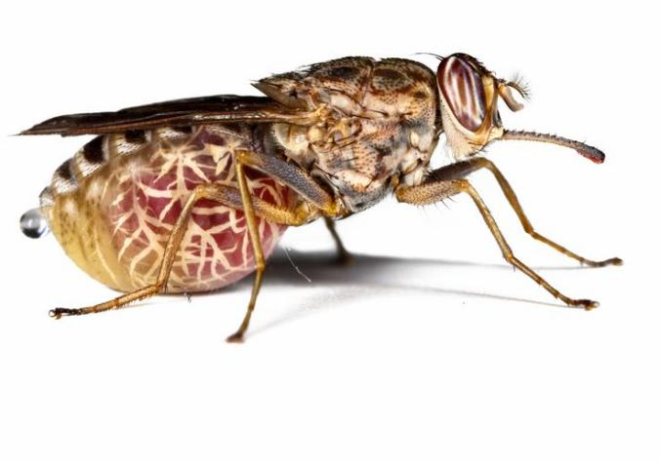

Fig.5: A male tsetse fly

- Fruit flies (drosophila –model organism)
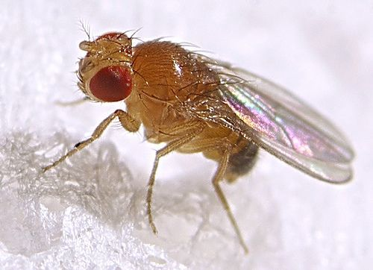
Fig.6: A fruit fly
2.5 Safety and Biosafety
- Biosafety levels (BSL-2 or BSCS) may apply if infected insects are used
- Strict protocol are followed to prevent vectors escape or disease transmission

CHAPTER THREE
PHOTOCHEMISTRY LAB
3.1 Introduction to Photochemistry Lab
This is a specialized lab dedicated to the extraction, identification, analysis and testing of plant-based chemical compound known as photochemicals for medicinal or biological purposes (Pan American Health Organization, 2023)
3.2 How Experiments are typically done in a photochemistry lab following a structured scientific method
- Selection and collection of plant material
- Choose the plant species based on ethno botanical or medical relevance
- Collect specific plant parts (leaves, stems, bark/roots, seeds, etc).
- Record collection data (data, location, species name).
- Preparation of plant material
- Washing and removing contaminant or dirt with water
- Drying: Shade drying or even drying at low temperature (below 50ºC).
- Grinding: Use grinder or blender to convert dried material into fine powder
- Storage: Store powdered material in an airtight containers, away from moisture.
- Extraction of phytochemicals
Goal: To dissolve bioactive compounds using suitable solute
The steps involved in this includes the following:
- Weigh a specific amount of plant powder (e.g 50g)
- Choose a solvent (e.g methanol, ethanol, water, hexane)
- Use an extraction method
- Maceration: soaking in solvent for 24-72 hours with occasional shaking
- Soxhlets extraction: continuous hot extraction using a soxhlet apparatus
- Percolation solvent is slowly passed through the plant powder
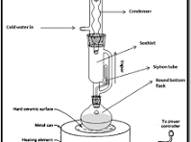

Fig.7: The soxhlet Extraction
- Photochemical screening (Quantitative Tests)
Goal: To identify the presence of bacteria compounds
Table 4: Common Quantitative Test
Compound | Test Name | Observation
Alkanoids | Wagners or Dragendorffs | Reddish-brown precipitate
Flavonoids | Lead acetate test | Yellow precipitate
Tannins | Ferric chloride test | Blue-black or greenish colour
Saponins | Foam test | Stable foam formation
Terapenoids | Salkowski test | Reddish-brown ring
Glycosides | Keller-killani test | Reddish-brown ring
Phenols | Ferric chloride test | Intense blue or green colour

- Quantitative Estimation
Goals: To measure the amount of each compound
Examples are:
- Total phenolic content : using folinciocaltue reagent
- Total flavonoid content: using aluminum chloride method
- Separation and purification: If isolation is needed,
- Use chromatographic techniques like TLC, column chromatography or HPLC
- Compare RF values and use specific spray reagents for identification on TLC plates
- Biological Activity Testing (optional): To evaluate medicinal potential
- Antioxidant assays (e.g OPPH scavenging activity)
- Antibacterial testing (e.g agar well diffusion method)
- Enzyme inhibition assays (e.g alpha amylase inbition)
- Recording and interpretation
- Record all observations, colour changes, weights, volumes and calculations
- Compare results with literature values
- Interpret presence and quantity of phytochemicals

CHAPTER FOUR
MOLECULAR LAB
4.1 Introduction to Molecular Lab
This is a specialized laboratory where scientists study and manipulate the molecular components of cells- especially DNA, RNA and proteins to understand how living organisms functions at a molecular level. (Lambert & Lanciotti, 2020)
  - Units of Molecular Lab
Steps in PCR Analysis workflow
Step 1: DNA Extraction:
- Collect biological samples
- Extract DNA using kit or manual method
- Measure DNA concentration (e.g nanodrop)
Step 2: Primer Preparation:
- Design or obtain forward and reverse primer
- Dilute to working concentrations (e.g 10 µm)
Step3: Prepare PCR master mix
Table 5: PCR Ratio
Component | Typical volume per (25µL r x N)
10x buffer | 2.5 µL
Mgcl₂ (25mM) | 1.5 µL
dN TPs (10mM each) | 0.5 µL
Forward primer (10 µM) | 0.5 µL
Reserve Primer (10 µM) | 0.5 µL
Taq DNA polymerase | 0.25 µL
Template DNA | 1-2 µL
Nuclease-free water | Up to 25 µL
Note: Include positive and negative controls
Step 4: Thermocycle Program
Table 6: Thermocycle Stages and Durations
Step | Temp(ºC) | Time
Initial denature | 94 – 95 | 2 – 5min
Denature | 94 – 95 | 30sec
Anneal | 50 – 65 | 30sec
Extend | 72 | 1min per kb
Repeat steps | ~30 – 35 cycles
Final extension | 72 | 5 – 10 min
Hold | 4 | ∞

Step 5: Gel Electrophoresis
- Prepare 1 – 2% agaross gel + DNA stain
- Load PCR product + loading cycle
- Run at 100 – 120v for 30 – 45 min
- Visualize bands under UV/blue light
Step 6: analyze results (DNA) sequencies.
- Compare to DNA ladder
- Check for correct band size, no non-specific bands, and clean negative control

4.3 Tools and Equipment in Molecular Lab
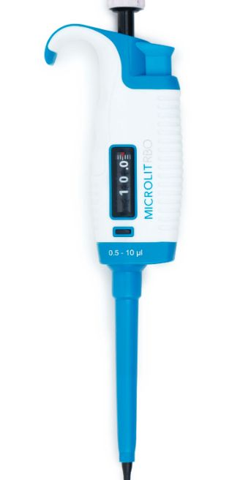
- Micropipettes and Tips

Fig.8: A hand-held Micropipettes

Uses of Micropipettes and Tips
- Used for accurately measuring and dispensing of liquids
- These are disposable plastic attachments used to hold and transfer the liquid without contaminating the pipette

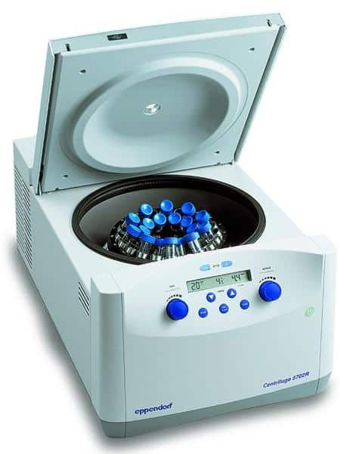
- Centrifuges

Fig.9: An image of a centrifuge

Uses of Centrifuges
- Pelleting cells before lysis
- Separating DNA/RNA from proteins and debris
- Collecting DNA after ethanol isopropanol precipitation

- Thermocyclers (for PCR)

Fig.10: A thermocycle
Uses of Thermocycles
- Used to rapidly heat and cool saples
- Amplifies specific DNA fragments through repeated heating/cooling cycles
- Converts RNA to complementary DNA (cDNA) using reverse transcriptase
- Used in techniques like site-directed mutagenesis to introduce specific mutations in DNA
- Amplifies DNA from different individuals to compare genetic markers
- Restrict digestion, ligation and heat inactivation of enzymes
- Spectrophotometers (e.g NanoDrop)
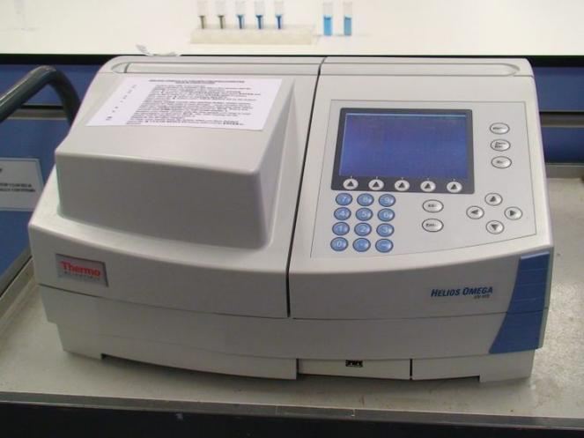

Fig.11: A Spectrophotometer
Uses of Spectrophotometers
- To measure the absence or transmission of light by a solution at a specific wavelengths
- Quantifying nuclic acids (DNA/RNA), proteins and assessing purity in molecular biology and biochemistry labs.
- Used for metabolic studies or inhibition assays.

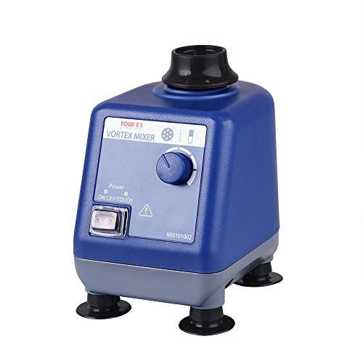
- Vortex Mixers

Fig.12: A Vortex Mixer
Uses Vortex Mixers
- Used to mix liquids quickly and efficiently
- Re-suspending pellets
- Help dissolve difficult or visions reagents fully before reactions.

  - Summary
As part of our academic exploration into vector-borne diseases, I participated in a field trip to the National Arbovirus and Vector Research Centre (NAVRC), located at 33 Park Avenue, GRA, Enugu. This reputable research institution is dedicated to the study, surveillance, and control of arboviruses—viruses transmitted by arthropods such as mosquitoes and ticks—which remain a significant public health concern in tropical regions like Nigeria.
During the visit, we were introduced to the foundational concepts of arboviruses, their transmission dynamics, and the importance of early detection and control strategies. The experience was further enriched by guided tours to three critical laboratories:
- Insectory Laboratory: Here, we observed how vector species (especially mosquitoes) are bred, maintained, and studied under controlled conditions. This facility plays a vital role in understanding the behavior and biology of disease vectors, essential for designing effective control measures.
- Molecular Laboratory: This lab is equipped with modern tools for genetic and molecular diagnostics. We witnessed demonstrations on how arboviruses are detected at the DNA/RNA level using techniques such as PCR (Polymerase Chain Reaction), which is crucial for accurate diagnosis and surveillance.
- Photochemistry Laboratory: The photochemistry section focuses on the study of natural compounds and their potential application in vector control and antiviral research. We learned about how plant-based extracts are analyzed for bioactive components that can serve as alternatives to synthetic chemicals in disease control.
Overall, the field trip provided valuable practical exposure to arbovirus research and control efforts. It deepened my understanding of the multidisciplinary approaches required in vector-borne disease management and emphasized the critical role of scientific research in safeguarding public health.
  - Conclusion
The field trip to the National Arbovirus and Vector Research Centre, Enugu, was an enlightening and impactful experience that broadened my understanding of arboviruses and vector research in Nigeria. Through direct exposure to specialized laboratories—namely the Insectory, Molecular, and Photochemistry labs—I gained practical insights into how scientific research is conducted to combat the spread of vector-borne diseases.
This experience not only reinforced theoretical knowledge from the classroom but also emphasized the importance of interdisciplinary collaboration in disease surveillance, diagnostics, and control strategies. The visit has sparked a deeper interest in public health research and has highlighted the critical role institutions like NAVRC play in addressing emerging and re-emerging infectious diseases within and beyond Nigeria.

REFERENCES

Hall, R. A., Blitvich, B. J., Johansen, C. A., & Blacksell, S. D. (2012). Advances in Arbovirus survelliance detection and diagnosis. . Journal of Biomedicine and Biotechnology. doi:https://doi.org/10.1155/2012/512969
Lambert, A. J., & Lanciotti, R. S. (2020). Laboratory Diagnosis of Arboviruses. Molecular biology evolution and control. (271-80). doi:https://doi.org/10.1775/978/91090210.15
National Arbovirus and Vector Research Centre. (n.d). Our history. Retrieved from National Arbovirus and Vector Research Centre: https://www.navrc.org.ng/about-navrc/
Pan American Health Organization. (2023). Recommendations for Laboratory Detection and Diagnosis of Arbovirus Infections in the Region of the Americas. IRIS.

